DA 6823

Kilger

Module 3: Part #1 (20 points)

**Statistical Significance Versus Effect Size + Independent Samples t test**

**General Instructions:** In your own words, answer each of the following questions - don’t copy (e.g. cut and paste) some definition out of a book word for word. This is not a group project – you are expected to complete this module on your own. You may refer to text books, online or other sources but not your fellow classmates. If you don’t understand the question, feel free to ask the instructor in class, in office hours or in an email.

Here is the SAS printout for an independent samples ttest that compares advertising receptivity (scale =person has low ad receptivity, 5=person has high ad receptivity) between males (gender=1) and females (gender=0).

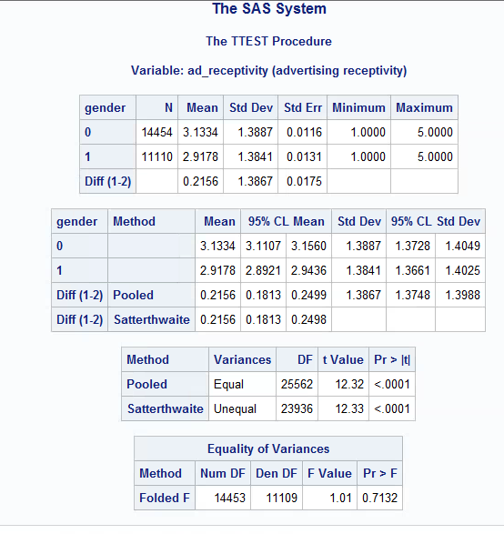

1. **State the null and alternative hypotheses for the 2 independent sample t test. (4 points)**

**Null:** The mean advertising receptivity in the population of males is identical to the mean advertising receptivity in the population of females.

**Alternative:** The mean advertising receptivity in the population of males is not identical to the mean advertising receptivity in the population of females.

1. **Name two assumptions of the 2 independent sample t test. (4 points)**

* A Dependent variable that is continuous
* Normal distribution (approximately) of the dependent variable for each group

1. **What is the mean ad receptivity for males? For females? (2 points)**

**2.9178** = mean ad receptivity for males

**3.1334** = mean ad receptivity for females

1. **Does the data suggest that the variance of ad receptivity in males versus females is to be treated as equal or unequal? What is the p value for this test? (4 points )**

**Null hypothesis of the Folded F test:** The variances are equal

**Alternative hypothesis of the Folded F test:** The variances are not equal

Because the p-value is greater than 0.05 (**0.7132**), we do not reject the null hypothesis, and conclude that the variance of advertising receptivity is **equal** for these two groups. This data suggests that the variance of ad receptivity in males versus females is to be treated as **equal.**

1. **What can you conclude about the differences in ad receptivity between males and females? Given the differences in the data between males and females, explain why you were able to come to the conclusion that you did. (6 points)**

Based on the Folded F test above, the **Pooled version** of the test statistic is selected. Because the Pooled p-value (**p < .0001**) is smaller than the significance level alpha **(.05**), we reject the null hypothesis, and conclude that **males and females had a statistically significant difference** in their mean advertising receptivity.

Based on the results, the mean advertising receptivity for females was 0.2156 units greater than the mean advertising receptivity for males.